
INTERNATIONAL CYBERSECURITY AND DIGITAL FORENSICS ACADEMY

ASSIGNMENT

Assignment Title: Number Systems, ASCII, Timestamps and Data Representation
Student Name: Ahmad Zubairu Garba
Student ID: 2025/FWSD/11463
Course Title: Basic Computer Skills for Digital Forensics
Course Code: SBT-DF201
Instructor: Aminu Idris

August 09, 2026

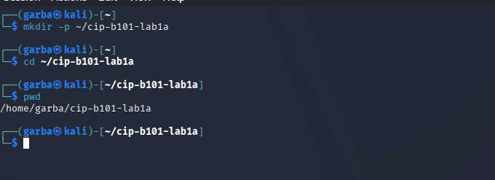

2. Task A - Number Systems and Manual Conversion
1. Convert 101010₂ to decimal manually:
  - $2^{5}\left(1\right)+2^{4}\left(0\right)+2^{3}\left(1\right)+2^{2}\left(0\right)+2^{1}\left(1\right)+2^{0}\left(0\right)$
  - $=32+0+8+0+2+0={42}_{10}$
2. Convert AB2₁₆ to decimal manually:
  - ${16}^{2}\left(\text{A}\right)+{16}^{1}\left(\text{B}\right)+{16}^{0}\left(2\right)$
  - $={16}^{2}\left(10\right)+{16}^{1}\left(11\right)+{16}^{0}\left(2\right)$
  - $=2560+176+2={2738}_{10}$
3. Convert 126₁₀ to binary manually by division by 2:
  - $126/2=63$ R $0$
  - $63/2=31$ R $1$
  - $31/2=15$ R $1$
  - $15/2=7$ R $1$
  - $7/2=3$ R $1$
  - $3/2=1$ R $1$
  - $1/2=0$ R $1$
Answer: ${1111110}_{2}$

4. Convert 2738₁₀ to hexadecimal manually by division by 16:
  - $2738/16=171$ R $2$
  - $171/16=10$ R $11$ ($\text{B}$)
  - $10/16=0$ R $10$ ($\text{A}$)
Answer: ${\text{AB2}}_{16}$
5. Convert 101010110010₂ to hexadecimal by grouping bits in fours from the right:
  - 1010 = A
  - 1011 = B
  - 0010 = 2
Answer: ${\text{AB2}}_{16}$
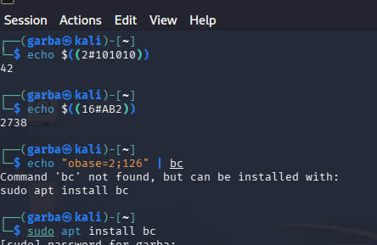

VALIDATION TABLE
1. Given Value: 101010 (Binary) $→$ Answer: $42$ (Verified using echo $((2#101010)))
2. Given Value: AB2 (Hexadecimal) $→$ Answer: $2738$ (Verified using echo $((16#AB2)))
3. Given Value: 126 (Decimal) $→$ Answer: $1111110$ (Verified using echo "obase=2;126" | bc)
4. Given Value: 2738 (Decimal) $→$ Answer: AB2 (Verified using printf "%X\n" 2738)
5. Given Value: 101010110010 (Binary) $→$ Answer: AB2 (Verified using python3 -c "print(hex(0b101010110010))")
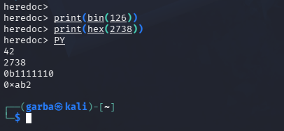
TASK B- ASCII, UTF-8 and Hex Evidence String

3.1 CREATE TEXT EVIDENCE AND VIEW AS HEX
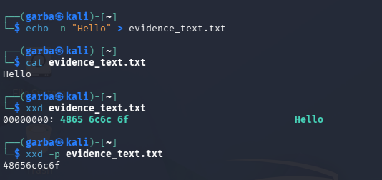
3.2 CONVERT HEX TO ASCII
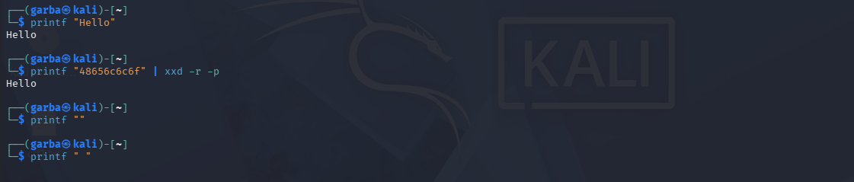
3.3 PYTHON CONVERSION
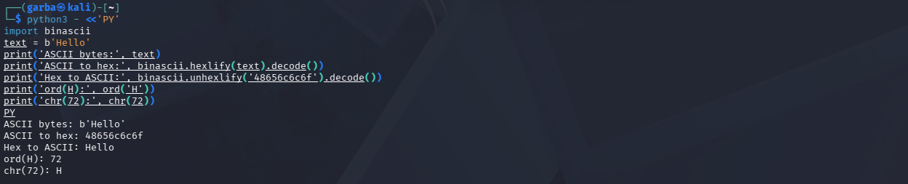
3.4 EXERCISE
- I created a file named ahmed_lab1a.txt containing the text: Digital Forensics Begins With Bytes using the command echo -n "Digital Forensics Begins With Bytes" > ahmed_lab1a.txt.
- I used xxd to display the file content in hexadecimal using the command xxd ahmed_lab1a.txt.
- I extracted the plain hex using the command xxd -p ahmed_lab1a.txt.
- I converted the plain hex back to readable text using the command printf "4469676974616c20466f72656e7369637320426567696e732057697468204279746573" | xxd -r -p.
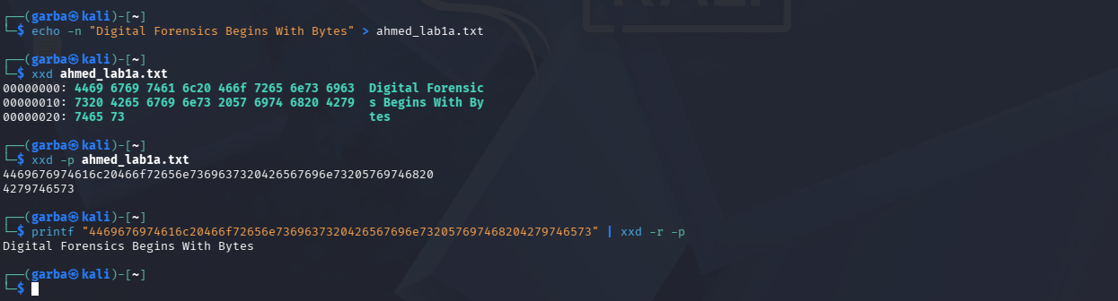
0A shows up at the end of the output when using echo without -n because the regular echo command automatically adds a hidden newline character (or line break) at the very end of whatever text you tell it to print.
TASK C
Unix Epoch Conversion
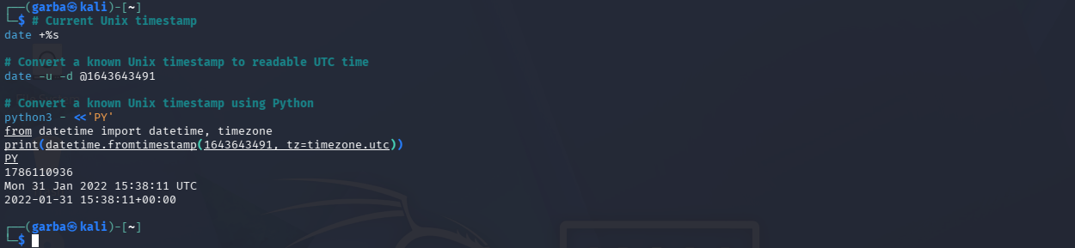
Compare Local Time and UTC
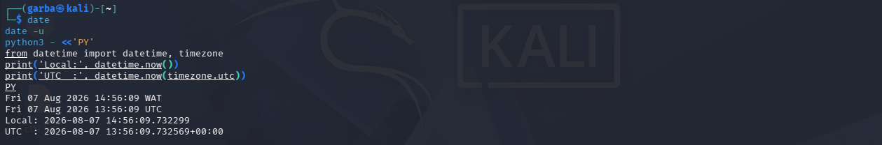
Mac Absolute Time/ Cocoa Core Date Offset
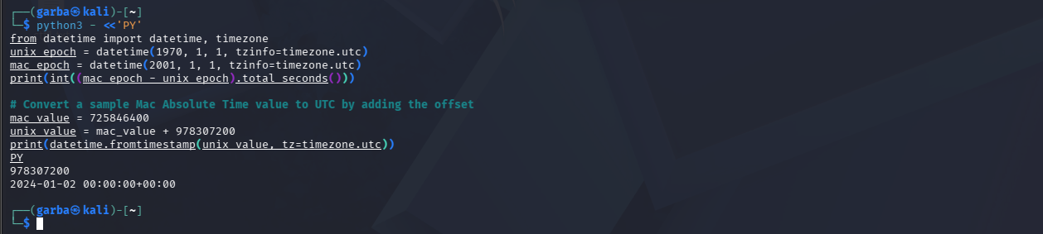

Raw Timestamp Value | Decoded UTC Time / Representation | Conversion Command | Screenshot Reference
1718448545 | January 31, 2022 15:31:11 UTC | date -r 1718448545 -u | 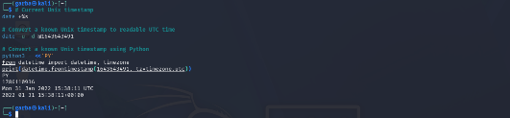
133631909450000000 | Friday 07 August, 2026 14:56:09 WAT | python3 -c "from datetime import datetime, timedelta; print(datetime(1601, 1, 1) + timedelta(microseconds=133631909450000000 / 10))" | 
13363190945000000 | Friday 07 August, 2026 13:56:09 UTC | python3 -c "from datetime import datetime, timedelta; print(datetime(1601, 1, 1) + timedelta(microseconds=13363190945000000))" | 
739978145 | January 02, 2024 15:31:11 UTC | python3 -c "from datetime import datetime, timedelta; print(datetime(2001, 1, 1) + timedelta(seconds=739978145))" | 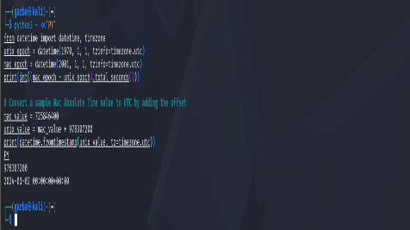

TASK D- HASHING AND THE NEWLINE PROBLEM
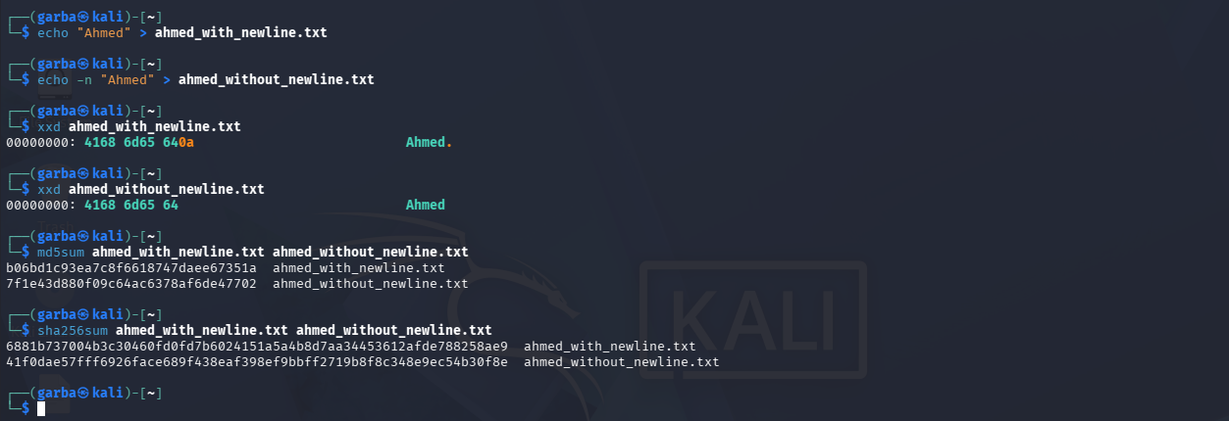
- The hash codes are different because cryptographic hashes look at every single byte in a file. The first file includes a hidden "enter" (newline) character at the end, while the second file only contains the raw text. Because the underlying byte sequence changes, the math behind the hash function produces a completely different output string.
- You would use echo -n because it prevents the terminal from automatically adding that hidden newline character at the end of your text, ensuring you are hashing strictly the characters you can see.
TASK E- ENDIANNESS AND DATA STORED IN MEMORY
6.1 Check Byte Order
- Command Executed:
python3 - <<'PY'
import sys
print('System byte order:', sys.byteorder)
PY
6.2 Interpret the Same Bytes in Two Ways
- Command Executed:
python3 - <<'PY'
raw = bytes.fromhex('78563412')
print('Raw bytes:', raw.hex())
print('Interpreted as little-endian:', int.from_bytes(raw, 'little'))
print('Interpreted as big-endian :', int.from_bytes(raw, 'big'))
PY
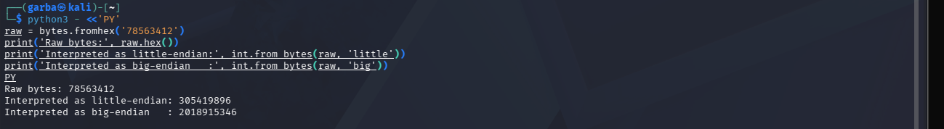
6.3 Student Exercise Table & Forensic Explanation
Raw Hex Bytes | Little-Endian Decimal | Big-Endian Decimal | Command Used | Explanation
01000000 | 1 | 16777216 | python3 -c "raw = bytes.fromhex('01000000'); print(int.from_bytes(raw, 'little')); print(int.from_bytes(raw, 'big'))" | Little-endian reads bytes right-to-left (01 is first), while big-endian reads left-to-right (01 is shifted to the highest place value).
FF000000 | 255 | 4278190080 | python3 -c "raw = bytes.fromhex('FF000000'); print(int.from_bytes(raw, 'little')); print(int.from_bytes(raw, 'big'))" | The significant byte FF is at the beginning, meaning little-endian treats it as a small value (255), while big-endian treats it as a massive number.
00000100 | 65536 | 260 | python3 -c "raw = bytes.fromhex('00000100'); print(int.from_bytes(raw, 'little')); print(int.from_bytes(raw, 'big'))" | The trailing 01 shifts position depending on the read direction, completely altering the math outcome.
78563412 | 305419896 | 2018915346 | python3 -c "raw = bytes.fromhex('78563412'); print(int.from_bytes(raw, 'little')); print(int.from_bytes(raw, 'big'))" | Reverses the bytes entirely (12345678 vs 78563412), showing how raw hex data flips values drastically.

The same sequence of four bytes can produce entirely different decimal values because endianness dictates the direction in which bytes are read and weighed.
Little-endian stores the least significant byte first, whereas big-endian stores the most significant byte first. While Forensic Relevance: When examining raw disk metadata, file headers, or memory dumps, a digital forensics analyst must know the system architecture. Misinterpreting multi-byte integers like file sizes, timestamps, or memory offsets by applying the wrong endianness results in incorrect values and flawed investigative conclusions.
TASK F- MINI FORENSIC INTERPRETATION CASE

